creation.
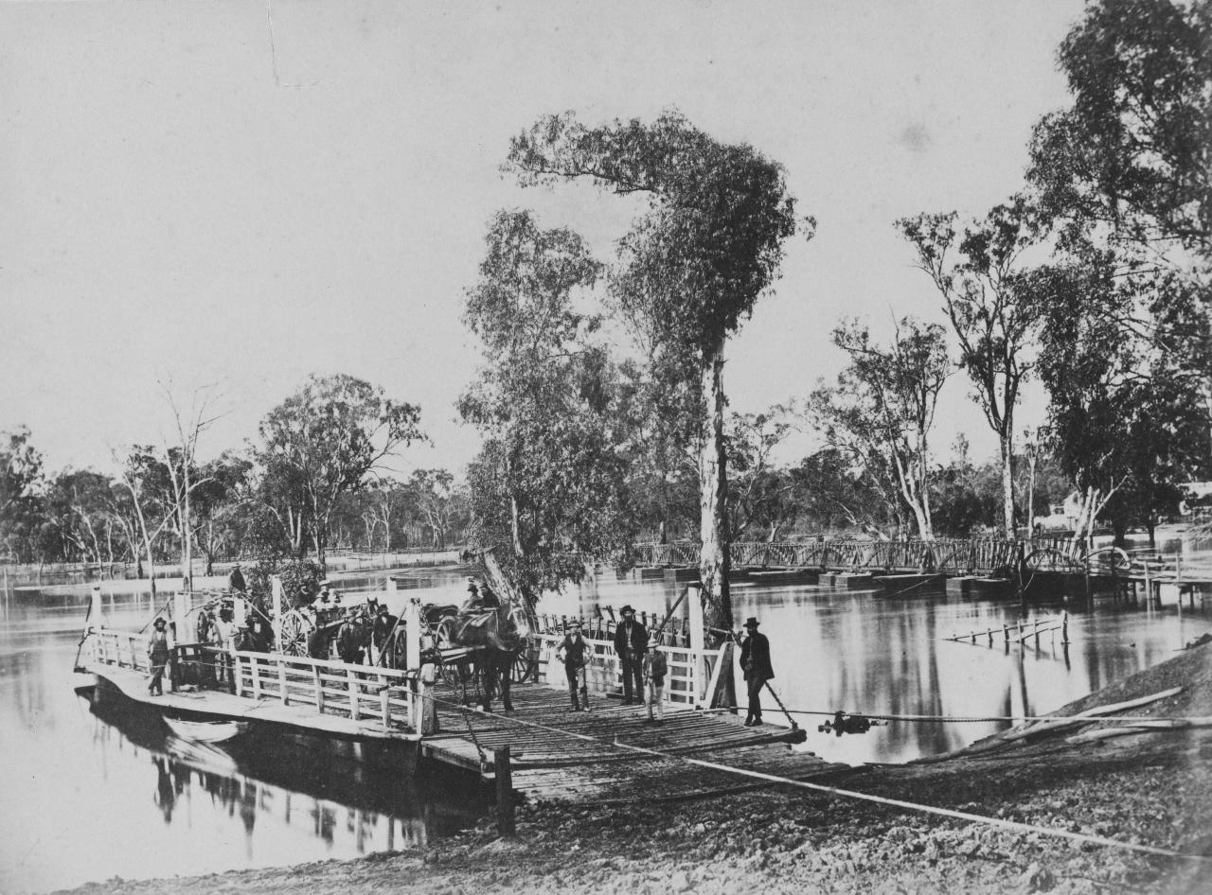
Nicholas CAIRE, The Punt, Echuca (c. 1876) | NGV [greyscale, cropped]

Gathering
+ Call to Worship
God be with you,
And also with you.

Informal words of welcome are offered.

Song #1— A song of praise

An acknowledgement of Country is offered,
appropriate to your local context;
an echo of God’s reconciling love
and the first fruits of our open hearts.

Opening Prayer
We pray the Psalm of the day,
followed by this prayer for the season:

Holy God, whose Spirit hovered
over the waters at the beginning,
we gather as part of your community
of all creation, thirsty for your grace.

We give thanks for the gift of water,
the veins of our common home,
that sustains the cedar and the whale,
the pasture and the city.

We are grateful for the local waters
that nourish our homelands
and our fellow creatures.

We give thanks
that in your well-watered garden,
every drop is a sacred testament
to your love.

We hold silence, and then offer prayers
of confession and lament,
paying particular attention to creation.
The prayer may conclude with these responses:

God, you are merciful
God, you are merciful

Christ, you are merciful
Christ, you are merciful

God, you are merciful
God, you are merciful
Amen.

God’s mercy flows like living water.

Water is poured into the font.

The love of God, incarnate in Jesus
who spoke to troubled waters,
forgives us and calms our hearts
so that justice may flow
to all the dry places in our lives.

Water is generously splashed onto the people, reminding us of our baptism

In the name of Christ,
may this grace free us to follow
and proclaim the good news
of the healing of all creation.

Hear Christ’s word of grace to us,
“Your sins are forgiven!”
Thanks be to God!

Word
Song #2 — A song of illumination

Contemporary witness
A word of testimony or story of creation may be shared.

Scripture
- First Reading
- Gospel

After each reading the reader may say:
Holy wisdom, Holy Word
Thanks be to God!

Preaching
Preachers are encouraged to remember God’s triune work of creation in their proclamation.
Response of faith

We believe in God,
who creates all things,
who embraces all things,
who celebrates all things,
who is present in every part
of the fabric of creation.

We believe in God
as the source of all life,
who baptizes this planet
with living water.

We believe in Jesus Christ,
seen in the suffering one,
the poor one,
the malnourished one,
the climate refugee -
who loves and cares for this world
and suffers with it.

And we believe in Jesus Christ,
the seed of life,
who came to reconcile
and renew this world
and everything in it.

We believe in the Holy Spirit,
the breath of God,
who moves with God
and who moves among
and with us today.

We believe in everlasting life in God.
And we believe in the hope
that one day God will put an end
to death and all destructive forces.

Notices and Offering
Notices from the community are shared,
and an offering taken.

If communion is not celebrated, the prayers of intercession might begin with thanksgiving for the life and gifts of the community.

Prayers of intercession
We offer prayers for the world, for one another, and for ourselves.
We pray especially for communities affected by climate change, and the renewal of God’s creation.
The prayer may include this response:

Where water flows, Lord,
let everything live,
trees for food
and leaves for healing.

We gather our prayers together
as your beloved Son teaches us:

Our Father in heaven,
hallowed be your name,
your kingdom come,
your will be done,
on earth as in heaven.
Give us today our daily bread.
Forgive us our sins
as we forgive those who sin against us.
Save us from the time of trial
and deliver us from evil.
For the kingdom, the power, and the glory are yours
now and for ever. Amen.

+ Thanksgiving
If communion is celebrated, it is placed here.

Sending
The people are sent with blessing and purpose, commissioned for the church’s ongoing work in the world.

Song #3 — A song of sending

+ Blessing and Sending
And may the Spirit
who hovered over the face of the waters
at creation,
at your birth
and your baptism,
grant you the gift of the freedom of Christ:
in the name of God,
who created you, who forms you
and who loves you.
Amen.
Go in peace,
as people of God made Christ's own through the waters of Baptism.
In the power of the Holy Spirit.
Alleluia! Alleluia!

The peace
The peace of the Lord be with you
And also with you.
We share a sign of peace with one another as we go.

Acknowledgements
This order of service is based on the ecumenical prayer service developed by the World Council of Churches (WCC). The contemporary kyrie is taken from the United Church of Canada; the Response of Faith is adapted from the Lutheran Theological College, South India.

