creation.
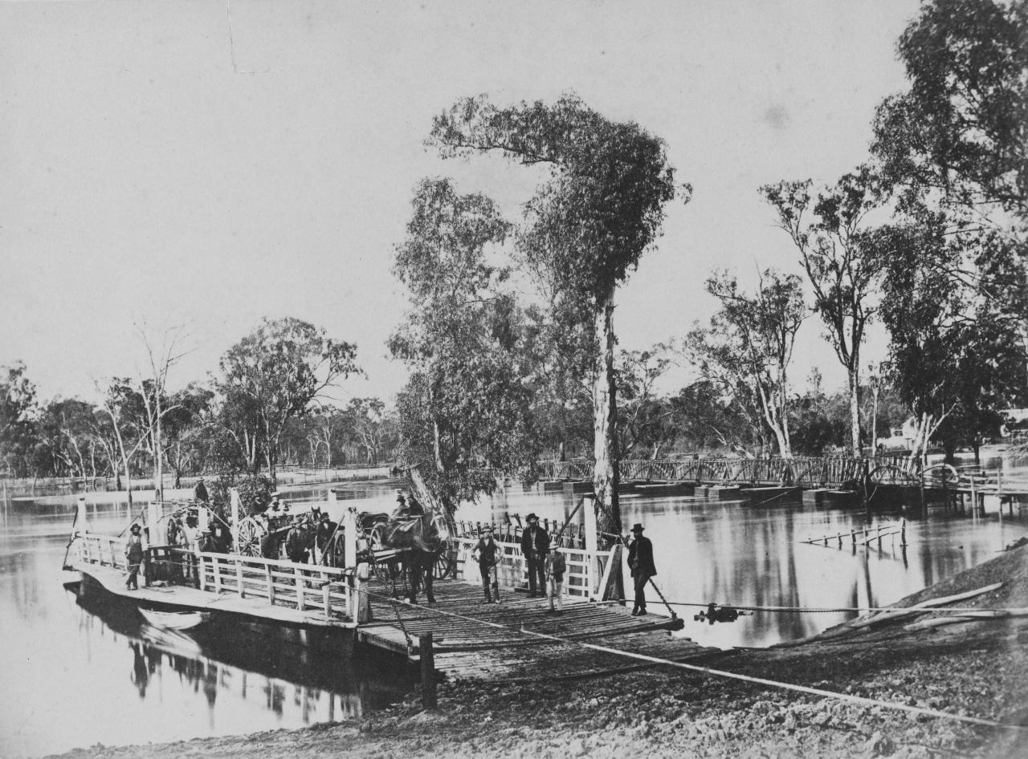
Nicholas CAIRE, The Punt, Echuca (c. 1876) | NGV [greyscale, cropped

Introduction.

All of our lives begin with creation. We are creatures of our Creator: formed from the dust, and always connected to the land. The Season of Creation is an invitation from the global church to rediscover our connection to God’s creation, and in so doing our connection to the Creator.

The Season of Creation runs from the Feast of Creation (1 September) to the Feast of St Francis of Assisi (4 October). Each Sunday between these two feasts congregations around the world are invited to attend more closely to creation, through our prayers and our reading of scripture.

This season is a powerful symbol of cooperation among churches globally, recognising that we all live in a shared world: the universal gift of our Creator, and the universal home for us to tend and share.

The Feast of Creation has its origins in the Eastern Orthodox celebration of “Creation Day.” And is a gift from the Eastern Church to the global church. This year the Feast of Creation in Christ has been added to the Revised Common Lectionary (RCL), and I highly encourage your local congregation to begin the Season of Creation with an emphasis on this feast (the readings are provided in this resource pack). You can read more about the Feast of Creation, and find a wealth of resources for marking the feast, here:
https://www.feastofcreation.com/

The broader Season of Creation traces a key part of its origins to the Uniting Church in Australia, particularly the Synod of Victoria & Tasmania. The season has blossomed to become both a gift and challenge to the church globally: to pay attention to what the patterns of creation are teaching us about God, and also the ways we need to take responsibility for tending to the garden of creation.

Creation is both beautiful and terrifying; powerful and fragile. The First Peoples of this land are deeply attuned to the ways Country is changing as drought, fires, and floods become more frequent and more intense. Our siblings across the moana of the Pacific currently live on the frontlines of the climate crisis; their homes and islands are being lost to rising oceans as they pay the price for global inaction on climate. This is an issue of justice at the heart of the Gospel. It is also a reminder that God’s wisdom continues to call us to right-making justice through the voices of First Peoples and our Pacific neighbours.

As we look to the celebration of the Season of Creation you are invited to make use of the resources published by the Pacific Conference of Churches. A wealth of further resources can also be found on the Season of Creation website: https://seasonofcreation.org/resources/

There are lots of ways your community might mark the Feast of Creation and the Season of Creation following after it, here are just a few:

- Use the Revised Common Lectionary (RCL) readings assigned for the Feast of Creation on the first Sunday in September:

First reading: Genesis 1:1-2:3 or Genesis 2:4-25
Psalm: Psalm 148:1-14
Second reading: Acts 17:22a, 24-28
Gospel: John 1:1-5

- Include the prayer, or part of the prayer, produced by the World Council of Churches in your opening prayer

- Use the simplified form of the service from the Pacific Conference of Churches Celebration Guide

- Draw on the wealth of resources online, or develop your own, to focus your services during the season on creation

Links to resources:
https://www.feastofcreation.com/
https://seasonofcreation.org/resources/

- Preach with an emphasis on ecology, creation care, and the mystery of creation throughout the season

May the blessing of God:
Maker of all things
Lover of all people
Breath of all life
be with you.
Amen.

- Matt Julius | Liturgical Renewal Project Lead

A Short Guide to the Simplified Order.

The simplified order of service is offered for use during the season of creation. The order is based on the resource developed by the World Council of Churches (WCC) in partnership with churches around the world - including in the Pacific.

The intention is that this order be used for the Feast of Creation on the first Sunday in September, and continues to be used throughout the Season of Creation (which ends on October 4). In using the same order for each week there are parts of the service that will change, and parts you are encouraged to journey with week after week.

The order is offered in 3 formats:

- Plain text (.doc)
- A version to be printed on A3 double-sided (PDF)
- A powerpoint version (.ppt)

The focus here is on simplicity, clarity, and sustainability. This service invites us to remember the waters of baptism which connect us to God. The waters flowing through Country which sustain our lives. The waters of the moana which connect us together.

The readings, the Psalm, the songs and parts of the opening prayer and prayers of intercession will change each week. This order encourages testimony or stories of creation, this may be about a recent encounter with God in creation, or a story of the local landscape.

Below you'll find a collection of resources for each week which you can swap out in the order.

The prayer for the season, declaration of forgiveness, affirmation of faith, and blessing you're invited to journey with for 5 weeks. Allow these words to become familiar and nourishing.

The elements on the service marked with a cross (+) are intended for the worship leader, the rest you are encouraged to distribute throughout the congregation.
In a larger congregation different people might give voice to different sections of the order.
In smaller communities different people might read different sections of the prayers where they are sitting.

The sections in bold are intended to be read together.

There is no need to read aloud the section headings; a simple prompt such as “let us pray” or “let us sing” might helpfully guide the service along.

Leaders should be mindful of symbols, body language and gesture: use water generously, a raised hand might symbolise forgiveness and blessing, open hands might reflect our openness to God in prayer.

Additional Resources.

6 September

Psalm 148:1-14
First reading: Genesis 1:1-2:3 or Genesis 2:4-25
Second reading: Acts 17:22a, 24-28 (optional)
Gospel: John 1:1-5

Prayer of Confession
From the Christian Conference of Asia ‘Asia Sunday Service’ (2023)

God of creation, we are at fault in the degradation of the planet
and for our lack of action, to defend and protect the world you have made.
We are guilty of contributing to global carbon emissions and to climate change.
We have been denuding our forests and mountains due to our greediness.
We are guilty of polluting the bodies of water for the sake of development.

Forgive us, O God.
For as humans, we think that we are the centre of your creation.
Forgive us, O God, for neglecting the rights of the earth and the rest of your
creation.
Forgive us, O God, for exploiting the earth’s resources for our human benefit.

13 September

Psalm 114
First reading: Exodus 14:19-31
Second reading: Romans 14:1-12 (optional)
Gospel: Matthew 18:21-35

Prayer of Confession
From the Anglican Church of Korea ‘창조절기 전례 자료’ (2024) [Liturgical resources for Season of Creation]

우주의 창조자이시며 생명의 본향이신 하느님,
주님의 세계를 우리에게 맡겨 그 생명을 돌보라 가르치셨나이다.
비오니 우리와 , , 더불어 숨쉬는 다양한 생명을 지키게 하시며
자신의 이익에 따라 생활하지 않고
창조세계를 보전하라는 사명을
우리의 십자가로 지고 주님을 따르게 하소서.
성부와 성령과 함께 영원히 사시며 다스리시는
우리 주 예수 그리스도의 이름으로 기도하나이다.
아멘.

Creator of the universe and source of life,
You have entrusted Your world to us, teaching us to care for its life.
We pray that you will enable us to protect the diverse life that breathes with us,
and not live for our own gain,
but to preserve the created world,
and to follow You by bearing this cross. We pray this in the
name of our Lord Jesus Christ, who lives and reigns with the
Father and the Holy Spirit, one God, forever and ever.
Amen.

20 September

Psalm 114
First reading: Jonah 3:10-4:11
Second reading: Philippians 1:21-30 (optional)
Gospel: Matthew 20:1-16

Prayer of Confession
From Rev. David Coleman (EcoCongregation Scotland) [adapted]

Sustaining God:
Inform us and teach us
to read the signs of sky and soil
that we rise to be friends, not slaves
of Christ, the Word become flesh;
and therefore listeners to
and protectors of our teachers:
fellow creatures and stakeholders
in your enduring Rainbow Covenant;

Hold us to account
for sin which kills what you sustain
for justice shirked
mercy despised

Hold us to account
for our entitled preference
for every arrogant transport
keeping our feet from humble walking
on your living holy ground:
that Common Home
you gift to all that lives
and breathes your praise.
Amen.

27 September

Psalm 78:1-4, 12-16
First reading: Exodus 17:1-7
Second reading: Philippians 2:1-13 (optional)
Gospel: Matthew 21:23-32

Prayer of Confession
From the Ecumenical Prayer for the Season of Creation 2026

We confess that we have treated the gift of creation as a mere commodity.
We have choked the seas with our waste and watched the warming tides rise in judgment.
We lament the cracked earth of the drought-stricked and the salty tears of the climate refugee.
Melt our frozen hearts, O God, and let the waters of repentance flow.

4 October

Psalm 19
First reading: Exodus 20:1-4, 7-9, 12-20
Second reading: Philippians 4:1-9 (optional)
Gospel: Matthew 21:33-46

Prayer of Confession
From ‘Uniting in Worship 2’ (CD)

We confess our sin, and the sins of our society,
in the misuse of God’s creation.

God our Father, we are sorry
for the times when we have used your gifts carelessly,
and acted ungratefully,
Hear our prayer, and in your mercy,
forgive us and help us.

We enjoy the fruits of the harvest,
but sometimes forget that you have given them to us.
Father, in your mercy:
forgive us and help us.

We belong to a people who are full and satisfied,
but ignore the cry of the hungry.
Father, in your mercy:
forgive us and help us.

We are thoughtless,
and do not care enough for the world you have made.
Father, in your mercy:
forgive us and help us.

We store up goods for ourselves alone,
as if there were no God and no heaven.
Father, in your mercy:
forgive us and help us. Amen.

