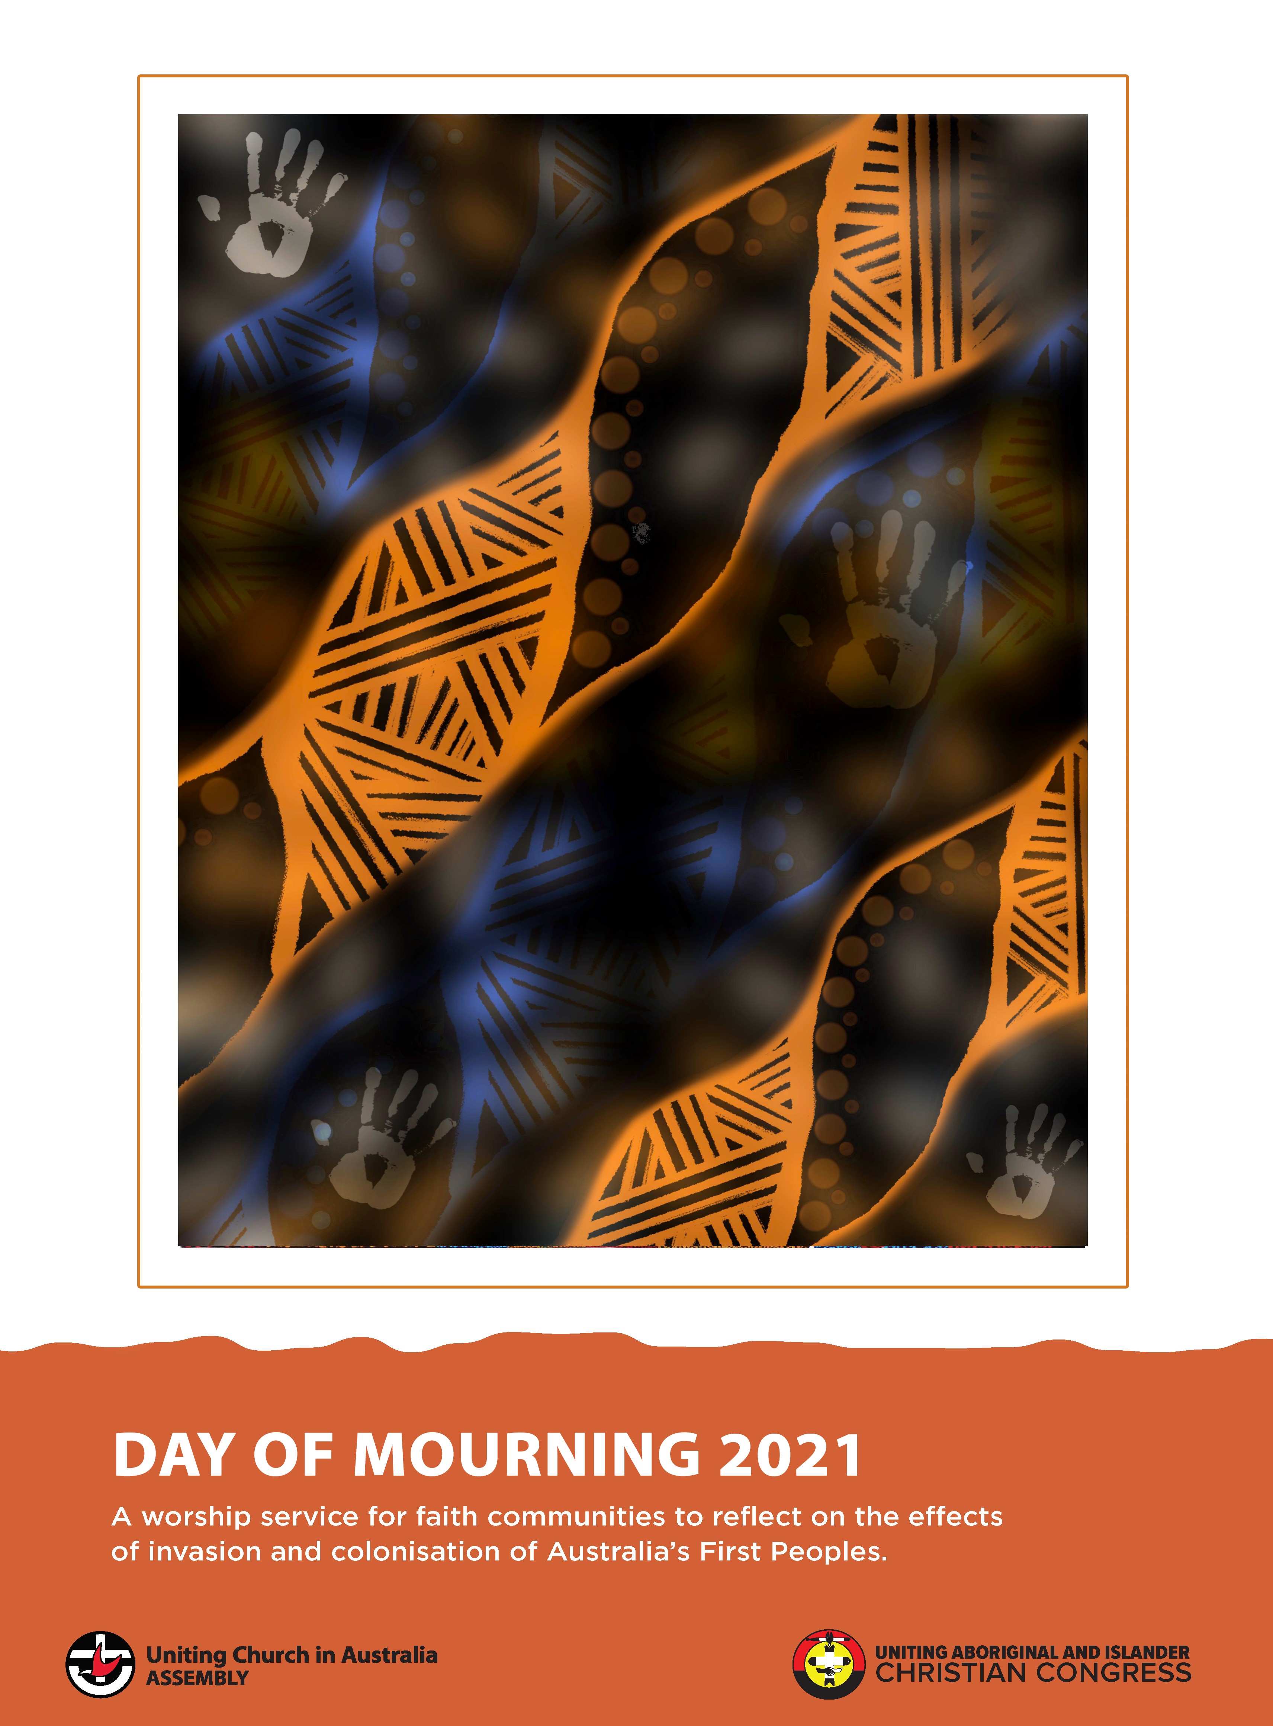
1

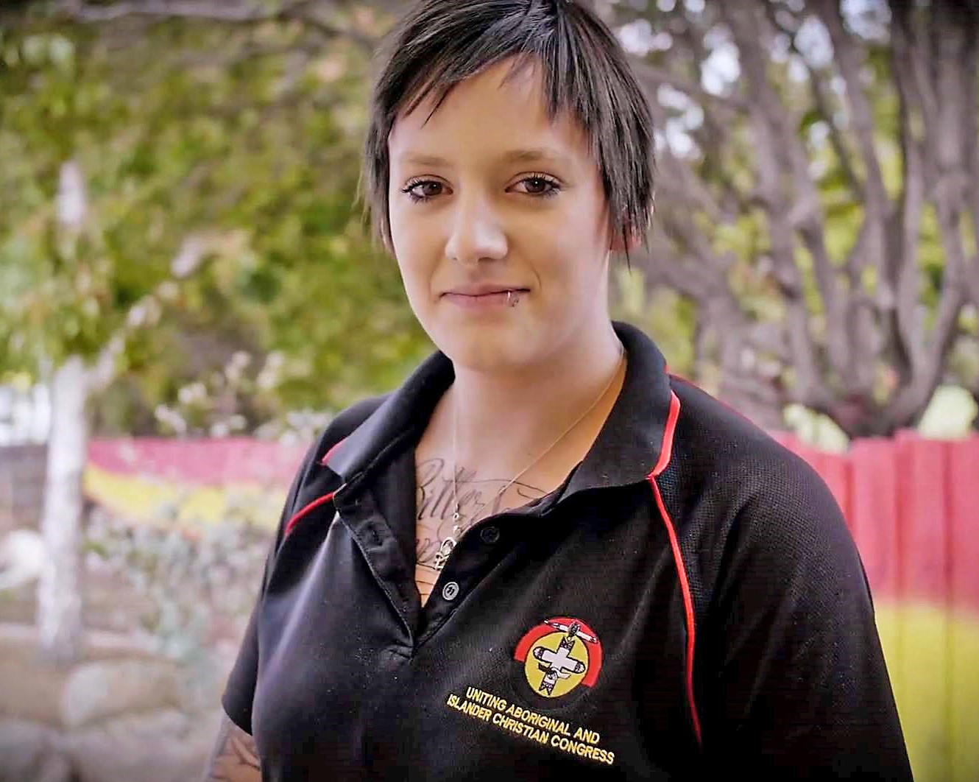
2

The meaning behind this art work is
interwoven story-telling. It makes a statement of:

“no matter what the history, this will always be aboriginal land, our imprint will never be invisible and we will always survive and
thrive. Our stories and family lines entwine
across seas, lands and skies, forever a united front.”

Grace Williams,
Community and Cultural Resource Officer, Leprena - UAICC Tasmania

DAY OF MOURNING Introduction
24 January 2021

The observance of a Day of Mourning was endorsed by the15th Assembly in 2018 arising from a request of the Uniting Aboriginal and Islander Christian Congress (UAICC).

In the spirit of our Walking Together as First and Second Peoples, and as an expression of the Uniting Church’s commitment to justice and truth-telling, we have declared the Sunday before Australia Day as a Day of Mourning.

This Day of Mourning Worship Resource invites all Uniting Church in Australia congregations to hold worship services that reflect on the effects of invasion and colonisation on Australia’s First Peoples and our identity as a nation.

This worship service is an annual observance for us as the Uniting Church. Remembering our history is an important part of our Covenant relationship and our journey toward justice, healing and a new relationship as First and Second Peoples. The service reminds us of the dispossession and violence against First Peoples, and laments that as a Church and as Second Peoples we were and remain complicit.

We acknowledged this in our Church when we apologised to the Stolen Generations in 1997.

We acknowledged this by revising the Preamble to our Constitution, which was approved by the 9th Assembly in 2009.

We acknowledged this in affirming First Peoples as the sovereign peoples of this land in 2018. Our declaration of a Day of Mourning allows us to stand together in remembering the truth of our history, and honouring the culture of Australia’s First Peoples, their families and the next generations.

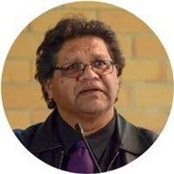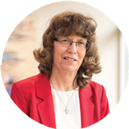
As the President of the Uniting Church and the Interim National Chair of the Uniting Aboriginal and Islander Christian Congress, we will be leading a livestreamed worship service, where we lament and invite Second Peoples to confess and ask for forgiveness, for the past and current impacts of colonisation and dispossession of Australia’s First Peoples.

We pray that our Church and our nation will continue on this journey of confession, truth- telling and working toward justice and healing.

Rev Dr Denise Champion, a Deacon in the UCA and an Adnyamathanha woman, speaks of the new community toward which we are called as the Uniting Church:
“I have been challenged in my work in facilitating reconciliation between First and Second Peoples, to create a safe community. A community where people can come together,
sit and talk, and experience healing and forgiveness for the past, finding a new destiny together.”

As the Uniting Church we affirm that ours is “a destiny together” acknowledging the wrongs of the past and the present and committing ourselves to take action to bring about a more just Australia. As the Uniting Church we hear Jesus calling us into the light of a new shared community, based on justice, love and mutual respect for one another. We pray that the whole nation may fully acknowledge our history and take a significant step towards healing for our nation.

We commend this resource to the Church. Grace and peace to you.

Dr Deidre Palmer / President Uniting Church in Australia
Ps Mark Kickett / Interim Chair Uniting Aboriginal and Islander Christian Congress

DAY OF MOURNING
Worship Resource

5

CALL TO WORSHIP

Our land is alive with the glory of God; desert sands hum and gum trees dance.

Brown grasses sing
and mountains breathe their stillness.
All created things add their rhythms of delight

and even stones rap out their praise.
Let our voices mingle with those of the earth; may our hearts join the beat of her joy,
for our triune God is with us:
the Source of all being surrounds and upholds us. (
Christ Jesus walks beside and before us.

The Spirit moves within and between us. Blessed be God, our wonder and delight.
CHILDREN AND FAMILIES:
Suggested actions for the inclusion of children in the service.
- Jump and throw your arms up high
- put your hand to your ear then loosen your fingers and wave your arms around
- cup your ear with your hand as if listening hard
- stand still and breath deeply
- tap rhythm sticks (or two small gum tree limbs), hit gum nuts with a small branch, whistle using a gum leaf or blade of grass.
- tap two stones together
- pretend to syphon dirt from one hand to the other

- make a heart shape with your hands and move it away from and then towards your body
- make a triangle with your hands
- give yourself a hug
- extend your arm as if putting it around a mate, then extend your arms as if placing your hands on someones shoulders
- wiggle your arm across your body
- hold your hands up high in the air

Other suggestions for a service that includes Children and Families can be found at the end of this document

ACKNOWLEDGEMENT OF FIRST PEOPLES
6

Today, as we gather to worship,
we acknowledge the peoples, the first inhabitants of this place
from time beyond remembering.

We acknowledge that through this land,
God nurtured and sustained the First Peoples of this country,
the Aboriginal and Islander peoples.

We honour them for their custodianship of the land on which we gather today.

We acknowledge that the First Peoples had already encountered the Creator God before the arrival of the colonisers;

the Spirit was already in the land, revealing God to the people through law, custom and ceremony.

We acknowledge that the same love and grace that was finally and fully revealed in Jesus Christ sustained the First Peoples
and gave them particular insights into God’s ways;

and so we rejoice
in the reconciling purposes of God

found in the good news about Jesus Christ.

OR

We acknowledge the Clan/Nation the sovereign First Peoples of this place.
We honour their elders past, present and emerging together with all descendants of this Nation,
for their care for these lands and waters since creation.

If there is a member of the recognised traditional owner Clan/Nation able to be present, then a Welcome to Country may be said first followed by the short form of the
Acknowledgement in response.

HYMN/SONG GREETING
Today friends, we are remembering the tragic history of our nation and the violent dispossession of her First Peoples.

Today is a Day of Mourning. Today we mark in lament the truth of our shared history and we lift up to God our prayers for First Peoples and our nation.

We say sorry and we pray for forgiveness, healing and hope. But today is also a day of worship. So we come together and give thanks to God for the abundant grace and liberating hope which we know through Jesus Christ and which is for all people.

The God of all justice, The God of all peace, be with you all.

And also with you.

BLESSINGS FOR A SACRED PLACE

Leader: Arrawatanha Ngapala Nguthana
Response: Most High
Our Maker
All: The land you have given us, your children.
Look on this place …
this special place where you live;
this special place where your glory rests.
Look upon this sacred place where your name is honoured.
Help us keep it as our Ancestors did.
Leader: Althaninda
Response: Happy are you.

In the Adnyamathanha language of the Flinders Ranges, SA, Arrawatanha means God/Most High and Ngapala Nguthana means Our Maker.
The meaning of Althaninda is Happy are you.

7

PRAYERS
8

INVOCATION

Abba, Father, Bäpa God, source of all life,
answer our call,
as a mother responds
to the cry of a child in the night.

Jesus Christ, brother and friend, Liberator,
stand beside us
as bearer of our humanity, and sharer of God’s grace.

Creator Spirit, giver of new life, purposeful guest, prod us to praise,
calling us to be a people
of hope and faith in Christ Jesus.

Amen.

Bäpa means Father in the Yolŋu languages of North Eastern Arnhemland

TRUTH TELLING AND AN INVITATION
9

Interwoven in the threads of mourning of the past, present and future; the cries of stolen lands
at the coloniser’s hands.

Mother Earth weeping in mourning: dispossession, forced removals and broken promises abounded.

Taken from the compass of land and lore, declared unfounded.

We mourn for our people;
we mourn for our loss and grief too.

We mourn for the cries echoing from the land, sea and sky, Creator Spirit we hear you.

A day of mourning is to hear those cries of the weeping land and First Peoples of this Land.

It’s to hear the stories of our ancestors and elders in the now.

It’s to hear and feel the cries with us as First Peoples.

It’s to know the resilience of our people and in the mourning of loss, to immerse in and engage with, the healing.

The celebration of not just a culture that’s survived but thrived;
within all the cries we see the hope.

The gift that First Peoples culture, history, struggle and resilience is to the wider church,
in all its fullness, richness, and truth-telling.

Mourn with us in the loss,
but walk beside us in the celebration and gift of healing the loss through honouring our stories,
our song lines, our “being and knowing “.

Mourn with us, Hear the cries,
But hear the justice and healing.

LAMENT AND CONFESSION

Merciful God,
10
we, the Second Peoples of this land, acknowledge and lament the injustice and abuse that has so often marked
the treatment of the First Peoples of this land.

We acknowledge and lament
the way in which their land was taken from them and their language, culture, law and spirituality despised and suppressed.

We acknowledge and lament
the way in which the Christian church

was so often not only complicit in this process but actively involved in it.

We acknowledge and lament that in our own time

the injustice and abuse has continued. We have been indifferent.

Gracious God, hear our acknowledgements — We have not loved you with our whole heart,

nor have we loved First Peoples and other neighbours as ourselves. God of mercy,
forgive us for our failures, past and present and give us the grace today to make a fresh start.

By your Spirit transform our minds and hearts so that we may love as you have loved us, that we may boldly speak your truth
and courageously do your will. Through Jesus Christ our Lord. Amen.
The gathered body shares this lament, saying it together.

RESPONSE BY FIRST PEOPLES
11

At this point in the service if First Peoples are participating they could be invited to offer a response to the lament and confession.

DECLARATION OF FORGIVENESS

This is the best of all:
When we are empty, God fills us;
when we are disheartened, God is compassionate; when we are wounded, God brings healing;
when we confess our sin, God forgives.

In Christ, through Christ and because of Christ, our sins are forgiven.

Thanks be to God.
You refill the cup of life, O God.
In Christ, we find refuge, strength and hope. Amen.

HYMN/SONG

THE SERVICE OF THE WORD BIBLE READINGS
Passages which could be used include:

Psalms 85: 7 – 13;
Micah 6: 6 – 8;
John 14: 15 – 24;
Acts 2: 1 – 21;
Romans 8: 19 – 27;
James 2: 14 – 26;
1 John 4: 7 – 21

Particular concepts may also be used, as follows:
Redistributive Justice – reparation, who is given the power, 2 Samuel 21 Nature of land, 1 Kings 21
Reparation Luke 19:1-10
Jubilee, a prophetic declaration for First Peoples, Isaiah 61:7-9 Luke 4:16-21 – “the year of the Lord’s favour” i.e. Jubilee (Lev 25)
Self-emptying God (kenosis) – in the “other”, Christ is revealed, Matthew 25:31-46
A Destiny Together – Basis of Union “the reconciliation and renewal of the whole creation.”, Psalms 78:1-8, 2 Corinthians 5:16-19 The Beatitudes Matthew 5:1-12
Further references: Mark 10:17-31, Luke 1:46-55 Sovereign God, God creates, preserves and saves. John 1; Psalms 19:1,2; Isaiah 40:22-31; Romans 8:19-21, Acts 17:22-28,

Preaching of the Word

Some resources for preaching could include:

Walking Together – Exploring the covenant between First and Second Peoples
https://ucaassembly.recollect.net.au/nodes/view/493

Building Partnerships – A guide to covenant renewal in the UCA
https://ucaassembly.recollect.net.au/nodes/view/288

Why Indigenous Sovereignty Should Matter to Christians
– Rev Dr Chris Budden https://www.mediacomeshop.org.au/test/index.php?route=product/ product&product_id=336

TIME OF SILENCE
12
The gathered community may be invited into a time of silent reflection

OFFERING NOTICES
PRAYERS OF THE PEOPLE

Give us the courage to
accept the realities of our history
so that we may build a better future for our nation. Teach us to respect all cultures.
Teach us to care for our land and waters.
Help us to share justly the resources of this land.

Help us to bring about spiritual and social change to improve the quality of life
for all peoples in our communities, especially the disadvantaged.
Help all young people to find true dignity and self-esteem by your Spirit.

May your power and love
be the foundations on which we:
walk together as First and Second Peoples; and build our families, our communities and our nation.

There could be a special offering for the work of the UAICC in your Synod or First Peoples community
organisation you have connected with.

Through Jesus Christ our Lord.
13
Amen.

SENDING FORTH OF THE PEOPLE OF GOD HYMN/SONG
WORD OF MISSION

People of God,
go from here to live out the covenant into which we, the First and Second Peoples of this land,
have entered with one another.
Confront and challenge injustice wherever you see it. Act justly yourselves and insist that others do the same.
Rejoice in the richness of our diverse cultures and learn from them. Celebrate and demonstrate the unity we share in Jesus our Lord.
Commit to worship, witness and serve as one people under God, Until God’s promised reconciliation of all creation is complete.

BLESSING

Bless us therefore, as we depart this place:
give us a generous spirit, a kind heart,
and the grace to walk alongside our First Peoples, as brothers and sisters in Christ. Amen.

DISMISSAL

Go in the power of God’s good Spirit:
with the gentle fire of God’s zeal, with the breath of life, ready to work for justice and peace.
We go in Christ’s name. Amen.

SUGGESTED SONGS:

Why Lord, O Why? by David McGregor:
Dropbox: https://www.dropbox.com/s/x856vr52899xuty/Why%20Lord%2C%20 O%20Why%3F%20VOCAL.mp4?dl=0

Youtube: https://youtu.be/LvhCTvt8wM0

How Shall we Sing? by Craig Mitchell and David McGregor https://craigmitchell.typepad.com/mountain_masala/2018/05/new-song-how- shall-we-sing.html

CHILDREN AND FAMILIES:

For an intergenerational service that helps Children and Families to fully participate, you might like to consider these ideas.

SUGGESTED ACTIONS FOR PRAYERS AND REFLECTIONS:

See above the Call to Worship suggested actions. Other suggested actions can be found here:

CRAFT ACTIVITY:

  - Ask your children to draw an Australian landscape as described in the Call to Worship, gum trees, desert sand, mountains etc.
  - Or bring with you pieces of native trees, sand, stones to look at or to use to make a picture.

ACKNOWLEDGEMENT OF FIRST PEOPLES

  - During the Acknowledgment of First Peoples you might like to read Welcome To Country By Aunty Joy Murphy and Lisa Kennedy by Walker Books
  - Watch Aunty Joy Murphy do a welcome to country here https://www.youtube.com/watch?v=NeBWuItrpW8

Make sure to emphasise that God was always in this Land.

TRUTH TELLING AND AN INVITATION

Ask children to listen to the words and look for emotions:
  - How do these words make you feel?
  - Do your feelings change as the poem is read?
  - Can you draw how they make you feel?
  - Describe those feelings
Suggested resource: You may like to use a set of emotional cards where children can point to the cards to show how they feel. For example: https://innovativeresources.org/resources/card-sets/bears-cards/

LAMENT AND CONFESSION
Children might pray as they continue working on their picture or focus on the leaves and rocks while they pray.
14

A shorter children’s prayer might be:

Great God,
Thank you for the (stone, rock, plants, mountains etc, name each in turn after the statement Thank you for)
Help me to share this land
And to learn from those who you first gave this land too. Help me to not forget past wrongs to the First People And not to repeat them
Amen (one clap, use clapsticks if possible)

BIBLE READINGS:

Suggested activities or resources for the bible passages suggested above:

Psalms 85: 7 – 13:
Make a heart card with a beautiful picture of something from Australia on it

John 14: 15 – 24:
Read/Watch Tina the Tree from the Lost Sheep website: https://www.lostsheep.com.au/stories/tina-the-tree/

Use the free downloads or buy the activity pack
  - how many acts of love did the tree do?
  - how many acts of love were done to the tree?

Romans 8: 19 – 27:
Watch Aboriginal creation stories on You Tube. For example:
  - https://www.youtube.com/watch?v=lDl5QwAR8DI
  - https://www.youtube.com/watch?v=0y3Ta5xcKV4

James 2: 14 – 26:
Read/Watch All These Things by Susie Poole: https://www.youtube.com/watch?v=wm5EUrLP9zY

Encourage role-play with toys where being kind can be played out. To explore the themes suggested:
Redistributive Justice:
  - Read The Day the Crayons Quit by Drew Daywelt https://www.youtube.com/watch?v=ZttMDho5HMw
  - Play with toys that encourage practicing interaction with others.
  - Or draw a colourful picture using all the colours

16

Self-emptying God:
Tell stories of how some has changed or life or how you changed life for someone.

A Destiny Together:
  - An alternative reading of the Beatitudes can be found in The Beginners Bible
Jesus Teaches on a Mountain pp.318- 321
  - Play with toys in a “garden” made from the twigs, leaves etc that you bought with you into worship.

PICTURE BOOK IDEAS

Sorry Sorry By Anne Kerr
https://www.booktopia.com.au/sorry-sorry-anne-kerr/book/9781925877359. html
Walking the Corroboree by Rhanee Tsetsakos and Anne Kerr https://www.booktopia.com.au/walking-to-corroboree-rhanee-tsetsakos/ book/9781925522747.html
Stolen Girl by Trina Saffioti, illustrated by Norma MacDonald https://www.magabala.com/products/stolen-girl
Stories for Simon by: Lisa Miranda Sarzin, illustrated by Lauren Briggs https://www.booktopia.com.au/stories-for-simon-lisa-miranda-sarzin/ book/9780143784258.html

TOY BOX ADDITION:
If your toy collection does not have First Nation dolls in it you might like to add to your collection. A place you can do that is here
http://www. gofairtrading.com.au/product/aboriginal-doll/ or https://www.teaching.com.au/ catalogue/mta/mta-aboriginal-dolls

ACKNOWLEDGEMENTS:
Truth Telling and Invitation: Alison Overeem, Manager, Leprena - UAICC Tasmania

Blessings for a Sacred Place: Rev Dr Aunty Denise Champion as part of the Uniting Aboriginal and Islander Christian Congress contribution to
Penelope Monger (ed.) Living Water Thirsty Land (Sydney: The Uniting Church in Australia Assembly, 2008), 90-91.

Prayers of the People: Prepared by the Wontulp
Bi-Buya Indigenous Theology Working Group, Amended September 2018 Assembly Resourcing Unit

Children and Families additions: Wendy Lewis, The Cross in my Backyard: https://thecrossinmybackyard.wordpress.com/
17

2021

