**TRANSPORT – AIR or OTHER**

*If you would like transport provided from and to Adelaide airport, please complete the following:*

Arrival date & time

………………………………………………………

Flight number

………………………………………………………

Departure date and time

………………………………………………..……..

Flight number

…………………………………………………..…..

If you are travelling by an alternative public transport, please provide relevant details here:

Arrival

…………………………………………………….…

Departure

………………………………………………………..

**Thank you.**

We are really looking forward to hosting our friends from interstate Synods.

**PAYMENTS**

We need to have registrations and payments received by **31st October, 2020**.

You may wish to register now with a $100 deposit and pay the balance of $525 by the 31st October deadline. [The deposit can normally be refunded if you need to cancel before the 31st October deadline.]

If a cancellation becomes necessary after the payment deadline, please let us know ASAP. Up to 25% of accommodation booked may be cancelled without penalty if advised by Dec 2nd.

To make your payment:

Either – complete the registration form and send it with cheque or money order to:

Uniting Church Adult Fellowships National Committee

c/- Mr Lindsay Parker

21 James St

Kingston (SE) SA 5275

Or – make a Funds Transfer payment to:

UCAF National Committee

BSB 035-804

Account 232992

Reference initial of first name plus full Family

name

And then – please email Lindsay at [lwparker@internode.on.net](mailto:lwparker@internode.on.net) to let him know who the payment is from.

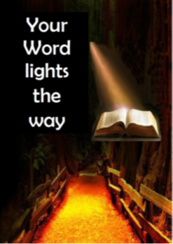

**UCAF**

**National Celebration**

**Wed 3rd to Sat 6th February, 2021**

**Ibis Hotel**

**Grenfell St., Adelaide**



**CELEBRATION HIGHLIGHTS**

* Bible Study
* Guest speakers from Frontier Services and UnitingWorld
* Fun, food and Fellowship
* Update on future structures of Adult Fellowships
* Celebration dinner
* Electives
* 10-minute walk to Adelaide’s cultural boulevard of North Terrace – libraries, Museum, Art Gallery and more, and the Botanical Gardens a few minutes further on.

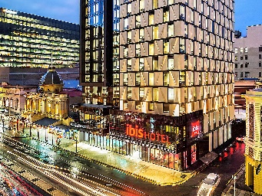 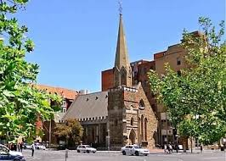

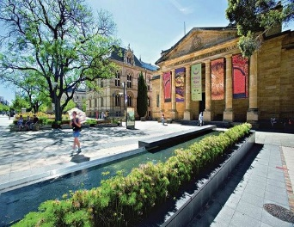 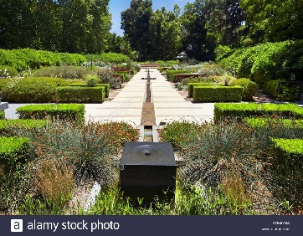

**CONFERENCE COSTS**

**FULL REGISTRATION**

Cost is $625.

Registration includes:

* Accommodation (twin rooms)
* All meals and refreshments
* All Celebration costs

Single accommodation is available – at an additional cost of $35 per day, $105 in total.

**DAY PACKAGE**

A **Day Visitor’s Package** is available:

$85 per day, including lunch, refreshments and Celebration costs.

Dinner is available at a cost of $45.

Parking is available in a nearby car park – both all-day and short-term rates; can be managed via the hotel desk.

**Event opening – 5pm:** worship and the commissioning of the in-coming National Committee. Depart hotel at 4.30: 10 minutes’ walk, transport available.

**ALL CELEBRATION ENQUIRIES to**

Max Howland

Ph: 0414 910 419

[max.howland@internode.on.net](mailto:max.howland@internode.on.net)

**REGISTRATION FORM**

Title ……………..

Name ……………………………………..

……………………………………………..

Address …………………………………..

……………………………………………..

Post Code ………….

Phone contact ……………………………

Live-in [ ]

Day visitor [ ]

Please indicate the name of any person you wish, or are happy, to share a room with:

……………………………………………..

***Food allergies or dietary needs***

……………………………………………..

……………………………………………..

Other matters we need to be aware of:

……………………………………………..

……………………………………………..

Request single accommodation [ ]