# **Uniting Church**

# **Adult Fellowship**

# **National Committee**

National CHAIR

***Janet Woodward***

Mobile: 0432 271 757

Email: [nationalpresidentucaf18@gmail.com](mailto:nationalpresidentucaf18@gmail.com)

National Secretary

***Max Howland***

email: [max.howland@internode.on.net](mailto:max.howland@internode.on.net)

This is a periodical newsletter from the UCAF National Committee. If you have something to share with the rest of Australia,

please send us an email:[*bfreeman@sa.uca.org.au*](mailto:bfreeman@sa.uca.org.au)

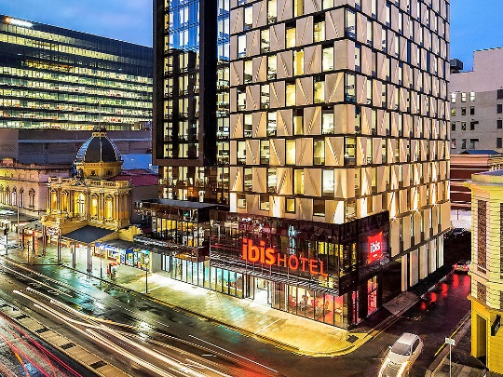 UCAF National Celebration

# February 3rd – 6th , 2021

Ibis Hotel, Adelaide CBD

# *“****Your word lights the path****” to a new start*

# *The National Celebration in April, will now take place directly after the National Consultation in 2021.*

**This will be a wonderful Celebration** – with Corona virus behind us, the start of a new year, the start of a new era electing new Office Bearers on National Committee for the first time. And with you here, what’s not to celebrate, so please come and join us! Everyone’s welcome to join in the fun, the food and the fellowship!

**CONFERENCE COSTS:**

FULL REGISTRATION $625.00

Registration includes:

* Accommodation (twin rooms)
* All meals and refreshments
* All Celebration costs

*Single accommodation can be arranged – please contact us for information about additional cost.*

DAY PACKAGE

A **Day Visitor’s Package** is available:

* $85 per day, including lunch, refreshments and Celebration costs.
* Dinner is available at a cost of $45.

*Parking is available in a nearby car park – both all-day and short-term rates; can be managed via the hotel desk.*

**ALL CELEBRATION ENQUIRIES to:**

Max Howland

Ph: 0414 910 419 [max.howland@internode.on.net](mailto:max.howland@internode.on.net)

***DEVOTIONS Eric Kirkham***

***But seek the welfare of the city where I have sent you into exile, and pray to the LORD on its behalf, for in its welfare you will find your welfare. Jeremiah 29:7 (NRSV)***

When this message came to the prophet Jeremiah the people were in a sad situation. They had been exiled from their homeland and were being held as hostages in a foreign land. Some of their leaders were predicting that the exile would not last long and they would soon be home. Jeremiah’s unenviable task was to remind them that this situation was not short term. Their godly response was to accept the situation and get on with life.

The situation we are in at the moment has a few parallels with being in exile. We are separated from family, our borders are closed and travel away from Australia is likely to be on hold for the foreseeable future. At such a time it is easy to get despondent or just pretend it will go away. We might wish that things will quickly return to normal but that seems unlikely. If we are to deal with any situation we have to first accept the reality.]

To arrive at a solution to a problem or issue we have to first face the issue. Whatever the issue, as Christians we don't face it alone. God’s wisdom and grace helps us move towards a new beginning. Lamentations reminds us, “**The steadfast love of the Lord never ceases, his mercies never come to an end; they are new every morning**”. (v3:22f)  In life, God’s love surrounds us and this gives us hope in every situation.

No matter how isolated or alone we might feel the love of God is always there with us. As Hebrews reminds us, **“Keep your lives free from the love of money, and be content with what you have; for he has said, ‘I will never leave you or forsake you.’”** 13:5 (NRSV) Our “normal” situation may never be the same again but one thing we can be sure of is that God will always be with us. God’s love and care is always present in all of life’s events.

**Hymn:** TiS. 211 Jesus, lover of my soul.

**Prayer;** Lord, we thank you that in all the changing scenes of life you are with us. Your love surrounds us and keeps us looking forward to the future with hope. You are the strength of all who put their trust in you; even in the gloomiest times your light shines on us. To you we offer our thanks and praise for the goodness and grace your presence brings. Our hearts are comforted as we pray in the Name of Jesus Christ our Lord. Amen

***Application are now open for:-***



**JOAN STOTT BURSARY for young adults under 35 years of age.**

Each year the Uniting Church Adult Fellowship National Committee offer up to two bursaries to the value of $1500 to assist those who are studying, or intending to study, in the field of leadership or theology within the Uniting Church in Australia.

National Secretary needs to receive applications by 31st July 2020. For further information, contact Max Howland: [max.howland@internode.on.net](mailto:max.howland@internode.on.net)

A Jar of Thanksgiving

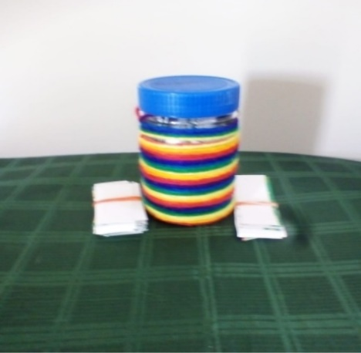

Spending more time in thanksgiving to God builds your immunity to withstand anxiety, stress, fear, and a sense of hopelessness. Vitamin C is to the physical body as Spiritual C (Christ) is to the soul, to keep us spiritually healthy. The *JAR*: ***J***esus; ***A***ll-powerful; ***R***eplenishes us when we spend more time giving thanks to Him. Less complaining and more of thanksgiving.

Four years ago, at 'Holiday with a Difference', a Retreat for Methodist church women, one of the presenters taught us how to make inspirational jars from discarded material. Among the women making jars were a 93-year-old woman and another in her late 20's with a broken leg. I found it interesting that nothing stopped these two women from being a part of the Retreat. Since then I have taught other women to make jars to serve several purposes. However, in January 2019 it made a significant impact on my life. After reading the Daily Bread Devotional on thanksgiving, I made a thanksgiving jar for myself and invited my neighbour to make one for herself. Just spending at least one minute each day to write a note of thanksgiving on a strip of paper I had cut from an old calendar, truly strengthened my walk with God.

I have seen so many impossibilities become possible. I invited the women's group at my church to make jars of thanksgiving before Covenant service, and the minister blessed the jars at the service. Some women shared with me the difference this simple act has made in their lives. Early this year, my brother came to visit, and I invited him to make a jar and he did without hesitation. The most touching part was, he returned to make two jars for two friends because using the jar had brought about a change in his life.

It is amazing how things that are insignificant, like old coffee or jam jars and old calendars, things we normally would discard, can be used to make a difference in our lives. As I reflect on Covid-19, I am reminded of Deborah the judge, prophetess, military leader, songwriter, and minstrel, a woman of humility with a heart of thanksgiving. Most of the judges in the book of Judges became leaders after a military battle. In the case of Deborah, she became a judge before the battle. In addition, she was the only one to be a judge and a prophet. Deborah settled disputes under the palm tree in the hills of Ephraim.

We now face the battle and disputes of Covid-19. People are locked in, locked down, and locked out. We are thankful to God that we can have worship services online. Just as Deborah held court beneath a palm tree, so we as women Chosen by God: Called to Proclaim we must find our “palm tree”; innovative ways to

settle disputes and be mediators. You can begin by making your own 'Jar of Thanksgiving' and sharing the idea with others.

Strengthening ourselves and others is important at this time to face the battle and disputes of Covid-19.

Deborah was chosen by God to use her gifts and skills to save His people, thus revealing the power of God.

Amidst it all, Deborah never forgot the power of thanksgiving:

*When the people offer themselves willingly,*

*Bless the Lord!*

*Hear, O Kings; give ear, O princes;*

*To the Lord, I will sing,*

*I will make melody to the Lord, the God of Israel. (Judge 5: 2b-3)*

God calls us to be bold like Deborah, “To know Christ and make Him Known”. Jesus All-powerful Replenishes us when we practice acts of humility and

THANKSGIVING to God.

-Lois Hector,

North America Area Vice-President.

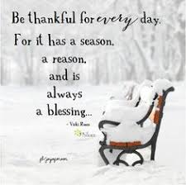It’s good to give thanks…..

* For the creativity that God has given us to adapt to our new way of life
* For the healing going on in the environment/wildlife
* For the selfless acts of so many people serving one another.
* Give thanks for those around us who are 'going the extra mile' to

bring a smile to the face of a neighbour or delivering groceries

for someone who is cocooning.

* + - Give thanks for the refuse collectors, men and women, and the

postal workers and other 'unsung heroes' who continue to do their jobs quietly as before, fulfilling a vital service to our communities.

* Give thanks for churches who are adapting to meet the needs of their congregation through online resources, phone-calls and sermons sent through the post. Praise God for the many people who come across these resources that would not normally be a part of a local church.

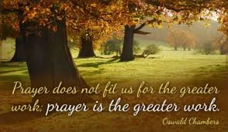And to pray for………

* Pray for families where there is abuse or neglect or the need for reconciliation, in particular for children in such homes during a lock-down where teachers and social services may not have as much contact with them, so that these situations may go undetected.
* Pray for those who have lost their jobs or who are facing a measure of uncertainty about whether or not they will be able to return to their work when this is all over.
* Pray for airline staff and those who work in the travel and tourism sectors. Pray for their sense of self-worth and purpose.
* Pray for those who feel lonely at this time, for grandparents missing their grandchildren and young people missing their friends.
* Pray for those who are learning to do their job in a different format- for teachers who are missing their children and are up-skilling and being as creative as possible as they teach online. For office workers working from home who no longer have the daily camaraderie of their co-workers at the desk beside them.
* Pray for those in government, for wisdom and discernment as they make decisions that affect the nations. Pray for their families too, who are also affected by the decisions that are made and the media that surrounds them.
* Pray for School Leavers, College and University students whose exams this year were not the usual format and who are worried about receiving predicted grades.
* Pray too, for those experiencing homelessness and those isolated by a lack of technology.

*From the pen of Carolyn Lawrence, President, Methodist Church in Britain*

Announcements

**!** **World Assembly postponed**

The World Executive met recently to discuss and evaluate the impact of the coronavirus pandemic worldwide. As a result, the World Executive has decided to postpone the 14th World Assembly to the 2nd – 7th August 2022.

These are certainly unprecedented times. A year ago, none of us imagined such a possibility. There is a lot of uncertainty around travelling abroad from different countries and it would be remiss of us to not consider this potential barrier. We always need to be prepared for the unexpected but be assured of God's guiding hand in all we do.

! Executive decision regarding its members: since the World Assembly will take place in 2022, the World Officers and Executive members will remain in office for an additional year.

**! HKMS process postponed**

**! Reminder**: You are welcome to contribute to the World Council of Churches campaign, the 'Tapestry' that is being made to support the Thursdays in Black. Women are invited to create a square panel with images and messages that show why they are involved in Thursdays in Black and to give a powerful message of their commitment to end rape and violence. All the sections will be joined for a huge exhibit, Waterfall of Solidarity and Resistance that will be displayed at the Ecumenical Centre in Geneva and at major events and will hopefully be displayed in Gothenburg in 2022. All the instructions are available on: <https://www.oikoumene.org/en/get-involved/thursdays-inblack/global-exhibit>

**FROM THE PRESIDENT**

Greeting from cold and wet South Australia. I guess the weather is the least of our worries at this time. We have all been through a very extraordinary time in the last three months and some of us are still on that journey.

As you can see from the front page of this Newsletter, we are stepping out in faith that all borders will be open so that we can meet in Adelaide in Jan/Feb 2021 for Consultation and Celebration. I am hoping that we will all be celebrating the life and work of Fellowship and Mission in Australia at that time. Also the return to a new normal in our lives.

Over the next few months we need lots of prayer as we will be considering who we would like to nominate for the three elected positions and for those we wish to nominate to join the National Committee as Synod Reps. There is one thing that sticks in my mind is that sometimes others see things in us that we don’t think we can do. Please be open if you are approached before you just say no. He asks for availability not always our ability.

For me this has been a time of much reflection on the journey from becoming the President and looking forward to the transition to the new structure. It has been very different for the fact that I have not been able to visit each state and see the work that is happening. To hear the stories and share the hard times and the joys of meetings. To wondering about what is going to happen when we start returning to church and fellowship after all restrictions have been lifted. To have made plans for Celebration and then it was postponed. It has been a very different world.

Through all this I know that God has been working in all that we have done while we have been home and restricted. He will strengthen us and guide us as we move along this journey with “Your Word Lights the Way”.

Blessings Janet

## **UC Adult Fellowship National Consultation – Jan 31st – Feb 3rd 2021**

**Ibis Hotel, Adelaide CBD**

This year will be like no other, as we move into the “new normal” that will be National Committee. No longer will National Committee be state based but rather nominated with elections held at National Gathering.

Nominations for National Chairperson, Secretary and Treasurer will be called from throughout Australia with two (2) representatives from each Synod making up the general membership of National Committee.

The program for the Consultation commences with a worship and welcome at 4.00pm on Sunday 31st January, and will conclude at lunchtime on Wednesday 3rd February. For those who can stay on, the National Celebration will commence on Wednesday afternoon 3rd February through till Saturday lunchtime 6th February.

On Wednesday 3rd February there will be worship at 5.00pm at Scots Church Adelaide for the conclusion of Consultation, commissioning of new National committee and commencement of Celebration.

The program has been set to incorporate all the business required while at the same time allowing some time for the valued fellowship for which these national events are renowned.

We have been able to negotiate a conference and accommodation package at Ibis Adelaide, right in the heart of Adelaide’s CBD so both the Consultation and the Celebration will be held in the one venue. Given that all travel plans have been on hold for some time now, we think that this is a great opportunity to come to Adelaide, stay for a week and enjoy South Australian hospitality and fellowship.

**Election of New UCAF National Committee 2021-2023**

Nominations are now open for the positions of National Chairperson;

National Secretary

National Treasurer

Nominations must be submitted on the approved Nomination Form with all parts completed and signed with a photo attached.

Nominations must be received no later than **31st October 2020** by the **Returning Officer,**

**Mission Resourcing, UCA Synod SA**

**312 Sir Donald Bradman Dr**

**BROOKLYN PARK SA 5032**

Email: [bfreeman@sa.uca.org.au](mailto:bfreeman@sa.uca.org.au)

Synod Committees are required to submit names of their two (2) representatives for National Committee by **31st August**, together with a 100 word profile and photograph. These names will be received by the Returning Officer, and presented to National Consultation 2021 for confirmation.

**UCAF National Committee**

**Nomination Form – 2021 - 2023**

***Please note***

1. The term of appointment for this triennium will commence on 31 March 2021.
2. Nominations will only be accepted from affiliated members of the UCAF and must be submitted on the approved Nomination Form to the Returning Officer by 31st October 2020
3. Nominees will indicate the position they are nominating for and include a profile highlighting the relevant gifts/talents they will bring to the role.
4. A Passport size photo of the nominee **must** accompany the nomination form.
5. Nomination forms must be signed by the Nominee, Proposer and Seconder. The Proposer and Seconder must be affiliated members of the UCAF.
6. The election of the office-bearers will be included in the business of the 2021 Consultation and will be conducted by written ballot.

**Attach photo here** We are nominating ________________________________________________ for the position of UCAF National Committee ___________________________

Nominee Signature: ________________________________ Date ___/___/____

Proposer: Name & Signature: ________________________________ Date ___/___/____

Seconder: Name & Signature: ________________________________ Date ___/___/____

**Nominee Details:**

|  |  |  |  |  |  |
| --- | --- | --- | --- | --- | --- |
| **Title** | Mr | Mrs | Ms | Miss | Rev | Dr | Prof (please circle) | | | | |
| **Surname** |  | | | | |
| **Given Names** |  | | | | |
| **Street** |  | | | | |
| **Suburb / Town** |  | | | Post Code |  |
| **Phone** | P: | B: | M: | | |
| **Email** |  | | | | |
| **UCAF Connection** | 1. I am affiliated with a Synod Committee / UCAF Group / Individual (please circle).      1. Name of Committee or Group, if appropriate:      1. Any position currently held in a UCAF Committee/Group: | | | | |

Refer over to complete Profile information.

UCAF NATIONAL COMMITTEE NOMINATION FORM Page 1

**Profile of Nominee** (Use an additional sheet if required).

1. Include a summary of the skills you will bring to the position you are nominating for, and
2. Information on any roles you have held within the UCAF and/or the Uniting Church.

|  |
| --- |
|  |

**Please email completed form by 31/10/2020 to the Returning Officer:**

* + Bev Freeman
  + 312 Sir Donald Bradman Dr, Brooklyn Park SA 5032.
  + bfreeman@sa.uca.org.au

**Check List:**

* 1. **Have all parties signed the Nomination Form?**
  2. **Has the Nominee’s Photo been attached?**

UCAF NATIONAL COMMITTEE NOMINATION FORM Page 2